URGENT! Pray & Fast for President Trump
January 30, 2018

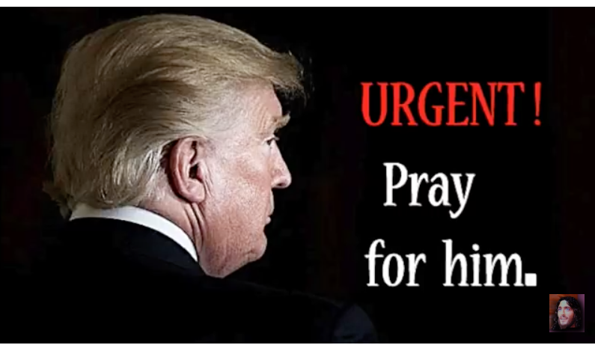
Heartdwellers, there's a plot out to kill the President by nuking Washington. North Korea is controlled by the Deep State and our Navy has a traitor high up that may not protect the President from the side that faces the sea.

President Trump is about to release a document of all the acts of Treason committed against the country by the Deep
State. They're going to try and stop him.

Please, fast and pray today and stand in the gap, that NOTHING. ABSOLUTELY NOTHING will harm our president and his administration.

PLEASE fast and pray with all your hearts to protect him. He has five days to release the document. He is in grave danger.

There are MANY less messy ways to do away with anyone, using Tessla technology. But I think this has something to do with politics concerning North Korea.

Nonetheless, he is in grave, grave danger.

Lord, have Mercy, have Mercy. Please, Lord, protect the righteous. And pray for those who will be convicted of these crimes, that they may repent and give their lives to Jesus before it's too late. He does not want any of them to perish, no matter how evil they've been. He still loves them.

Please, pray for mercy for them as well.

Whatever you can offer the Lord as a fast offering, please offer it.

God bless you, Heartdwellers. We're going to be in prayer all day today. The danger may not be over until after he's released the document.

So, please be on the alert and stay prayerful for the next few days, 'till this is over.

